<http://total-qa.com/performance-testing-using-jmeter-selenium-webdriver/>

V.Good:

<https://www.youtube.com/watch?v=uxQhPekuJAY>

<https://www.softwaretestinghelp.com/integrating-jmeter-selenium/>

<https://www.blazemeter.com/blog/how-install-jmeter-plugins-manager>

<https://www.youtube.com/watch?v=uxQhPekuJAY>

<https://www.youtube.com/watch?v=W5U-q3ATfb8>

<https://www.youtube.com/watch?v=zZgUe17PgHo>

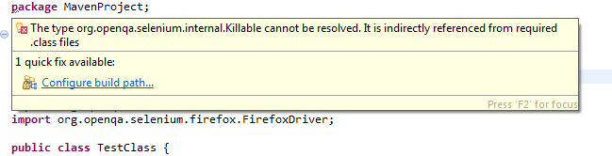

The type org.openqa.selenium.internal.killable can not be resolved